Exploitation & System Security
Jemimaal.R
B.Sc. IT

INDEX

SR.NO | TITLE | PAGE NO.
1 | Penetration Testing Methodology | 2
2 | Exploitation with Metasploit | 4
3 | Password Attacks | 9
4 | Social Engineering (Simulation Only) | 12
5 | Malware Basics | 14
6 | System Hardening | 16

Exploitation & System Security
TASK – 4
STEP: 1 - PENETRATION TESTING METHODOLOGY
- Objective: Understand the workflow: Recon → Scanning → Exploitation → Post Exploitation → Reporting

- Penetration testing follows a systematic approach to identify and exploit vulnerabilities in a target system. The first phase was reconnaissance, where information about the target system was gathered.
- The second phase involved scanning the target to identify open ports and vulnerabilities. The exploitation phase involved using known vulnerabilities to gain unauthorized access to the target system.
- After successful exploitation, post-exploitation activities such as gathering system information and maintaining access were performed. Finally, all findings and observations were documented in a detailed report.

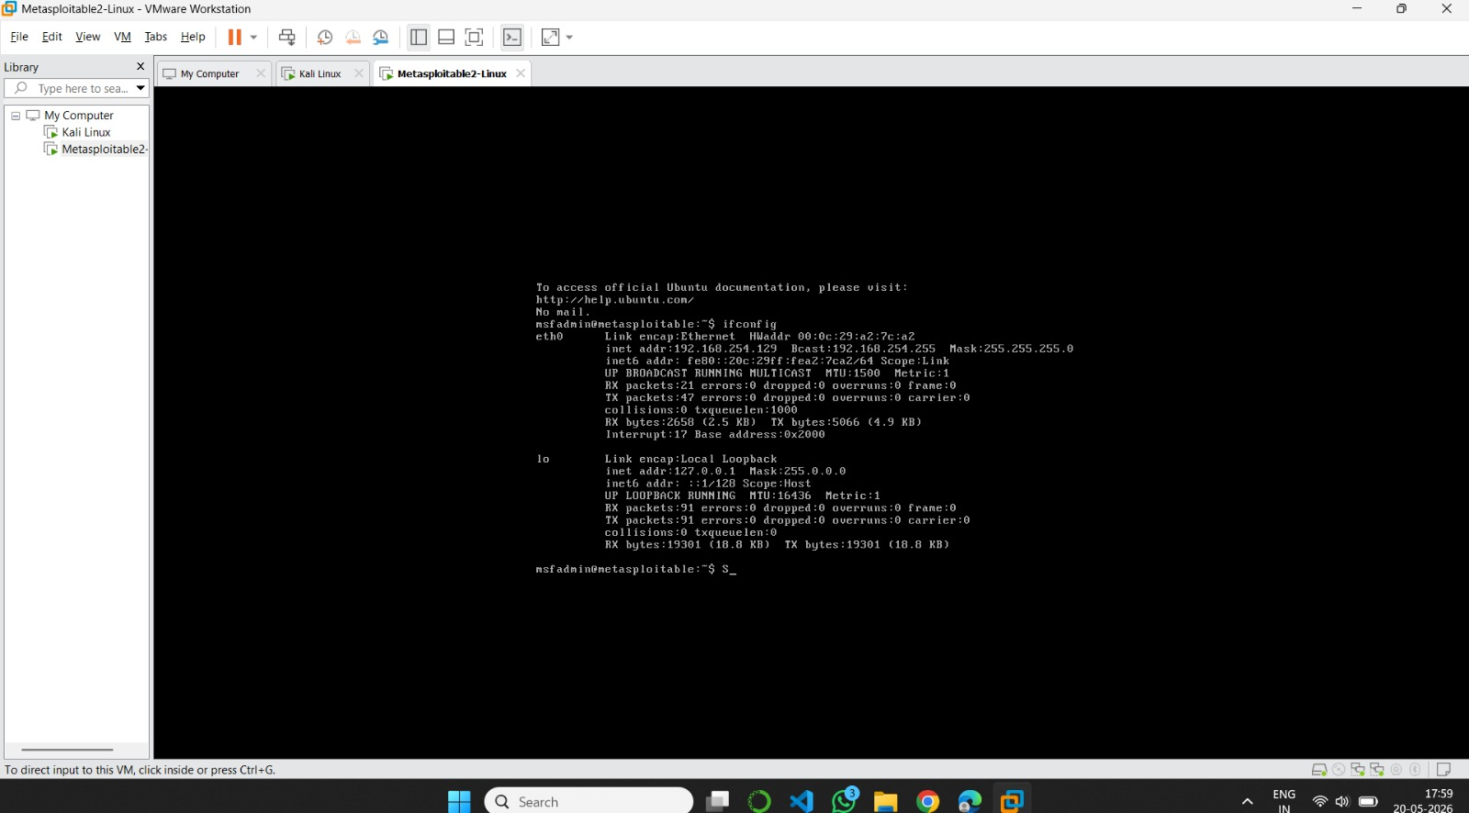
Fig 1: Metasploitable

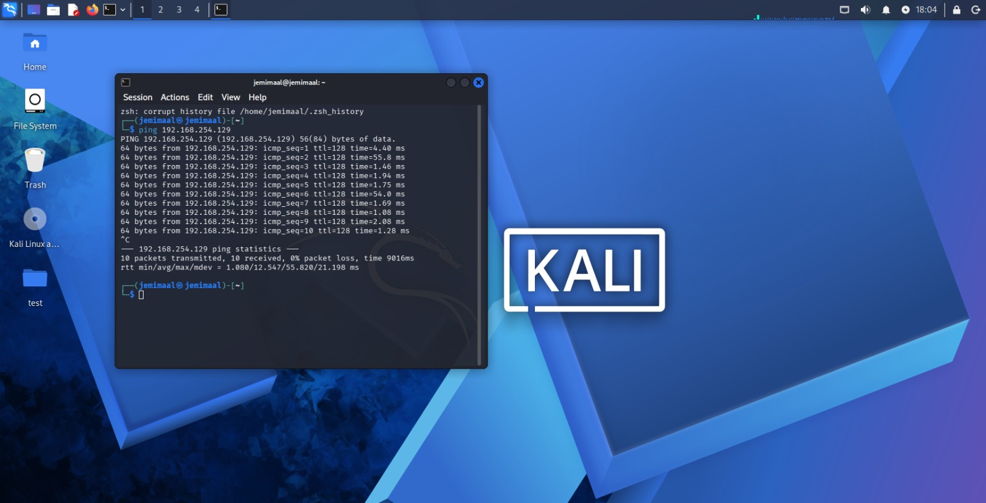
Fig 2: ping

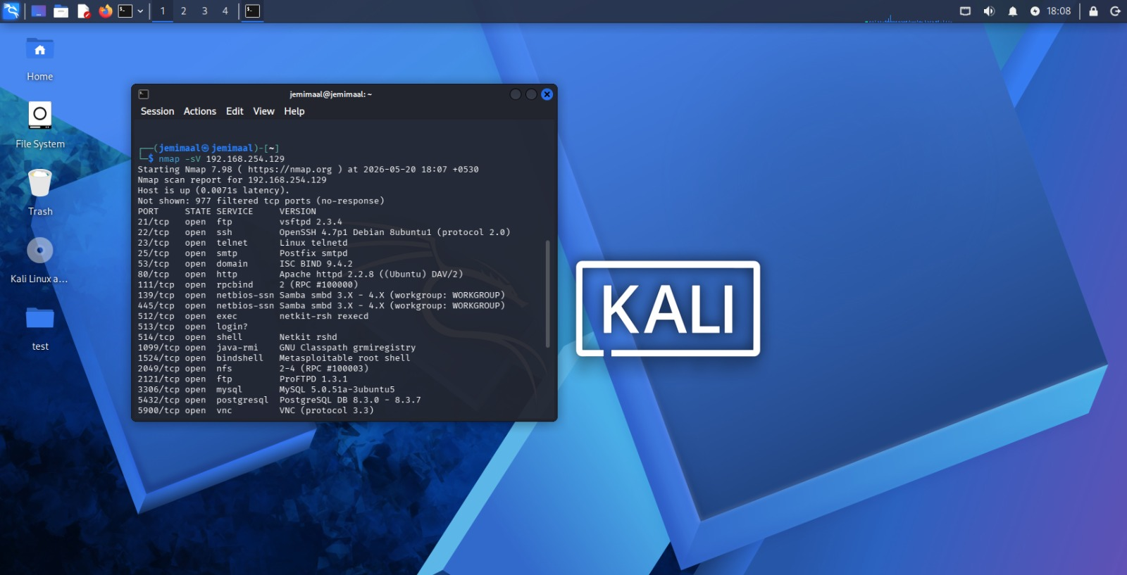
Fig 3: nmap

STEP: 2 - EXPLOITATION WITH METASPLOIT
- Objective: Exploit a known vulnerability safely in Metasploitable2.

- Metasploit Framework was used to understand how vulnerabilities can be exploited in a controlled environment. The Metasploit console was launched in Kali Linux, and suitable exploit modules were searched and selected.
- The exploit was configured using the required parameters such as target IP address and payload options. After running the exploit, access to the vulnerable system was achieved successfully.
- Post-exploitation commands like “sysinfo” and “hashdump” were also executed to gather system-related information.
The following commands were used during the activity:
- msfconsole
- search vsftpd
- use exploit/unix/ftp/vsftpd_234_backdoor
- show options

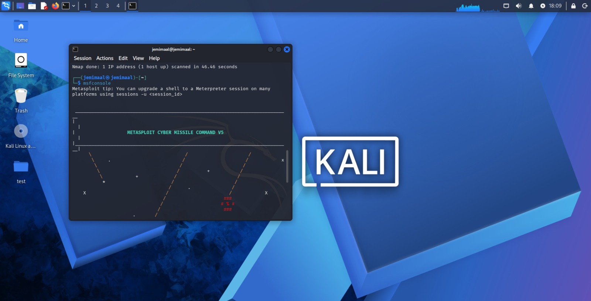
Fig 4: msfconsole

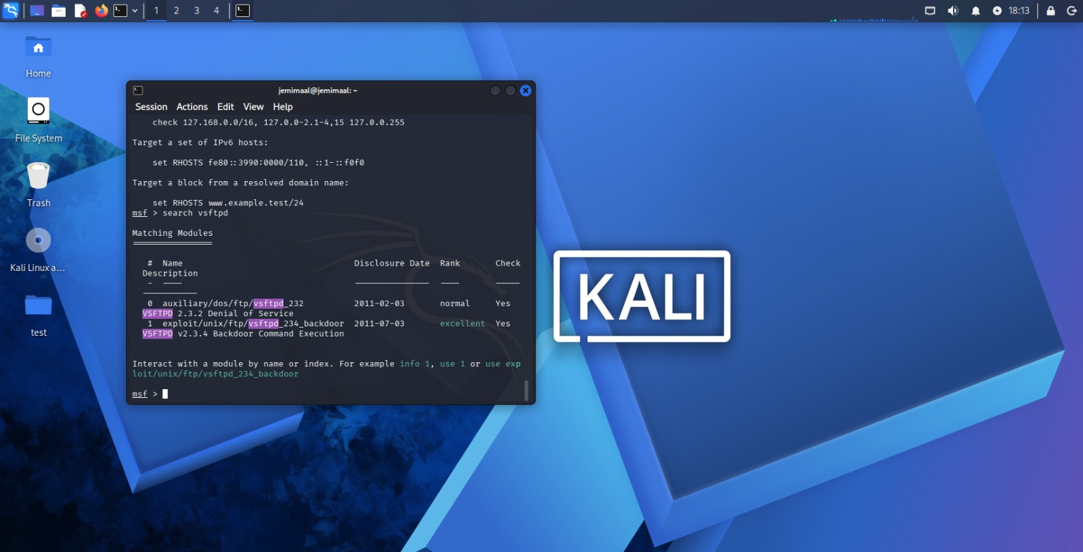
Fig 5: search vsftpd

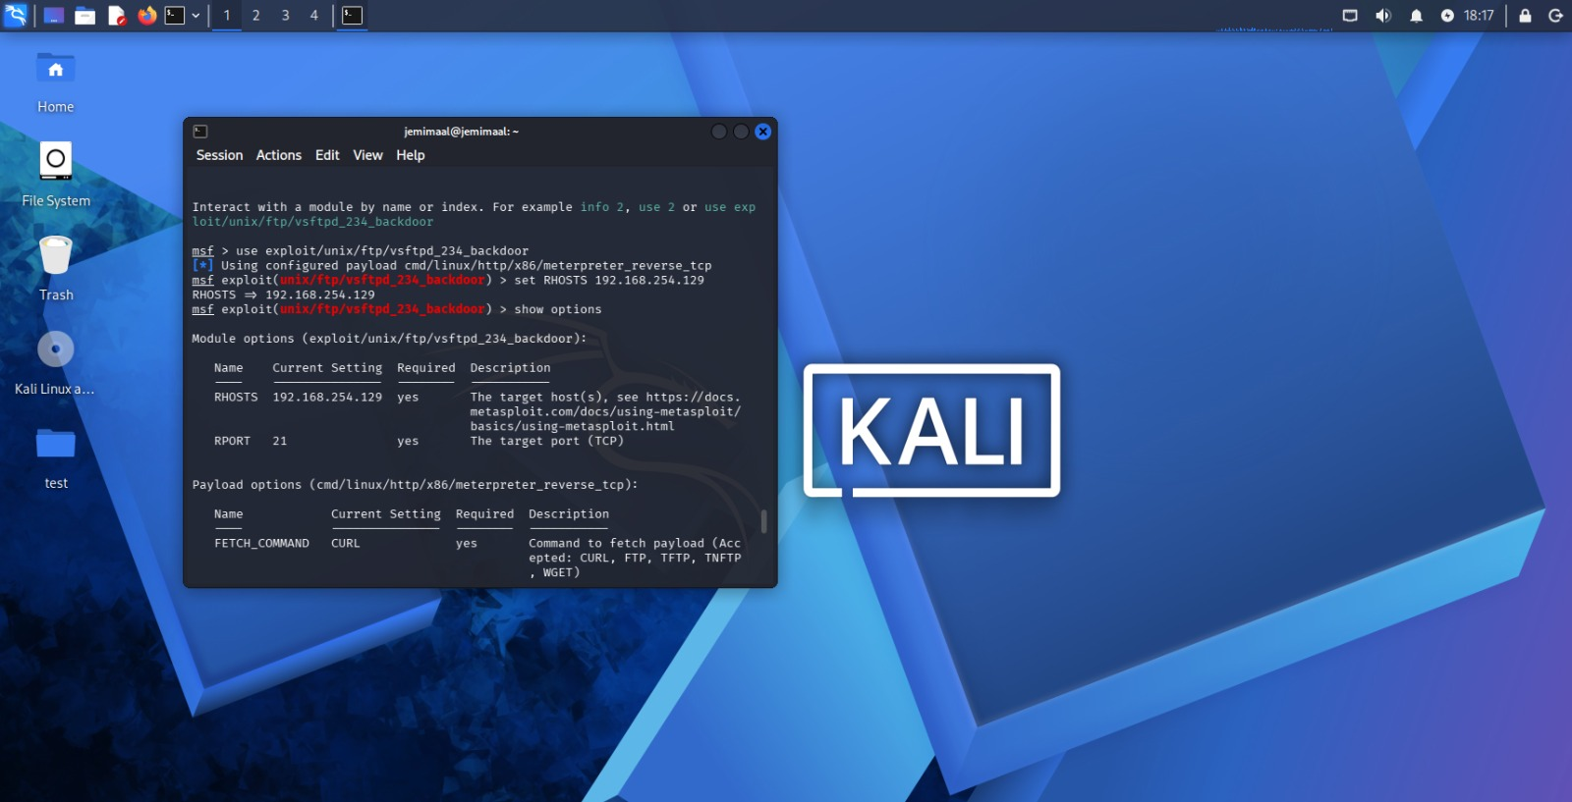
Fig 6: use exploit , show options

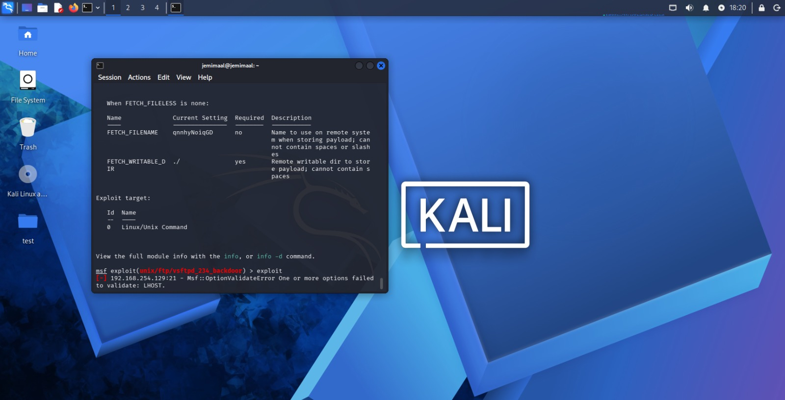
Fig 7: exploit

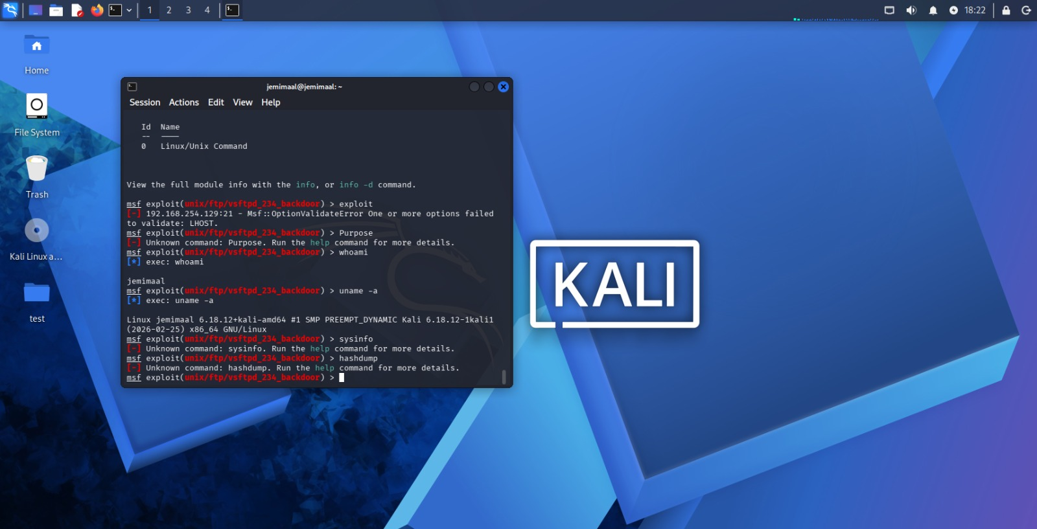
Fig 8: sysinfo , hashdump

POST EXPLOITATION
- Objective: Run basic commands after exploitation, Perform vulnerability exploitation using the Metasploit Framework.

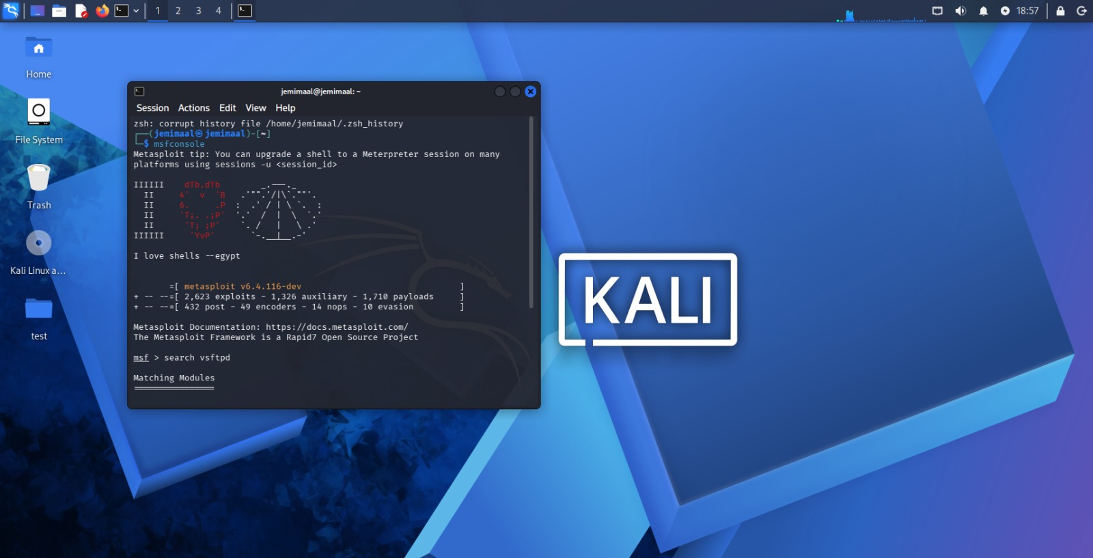
Fig 9: Launch metasploit

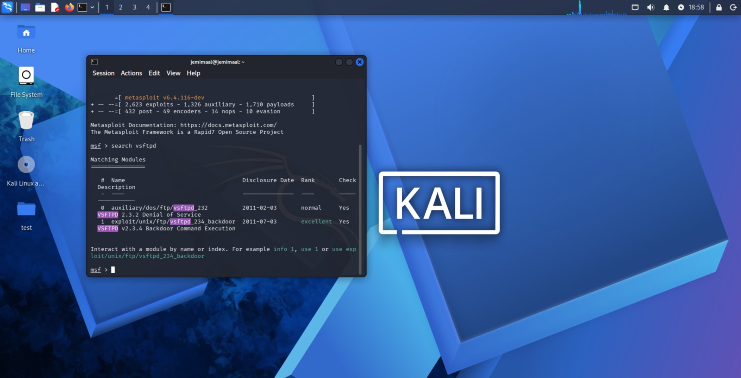
Fig 10: Search Exploit Module

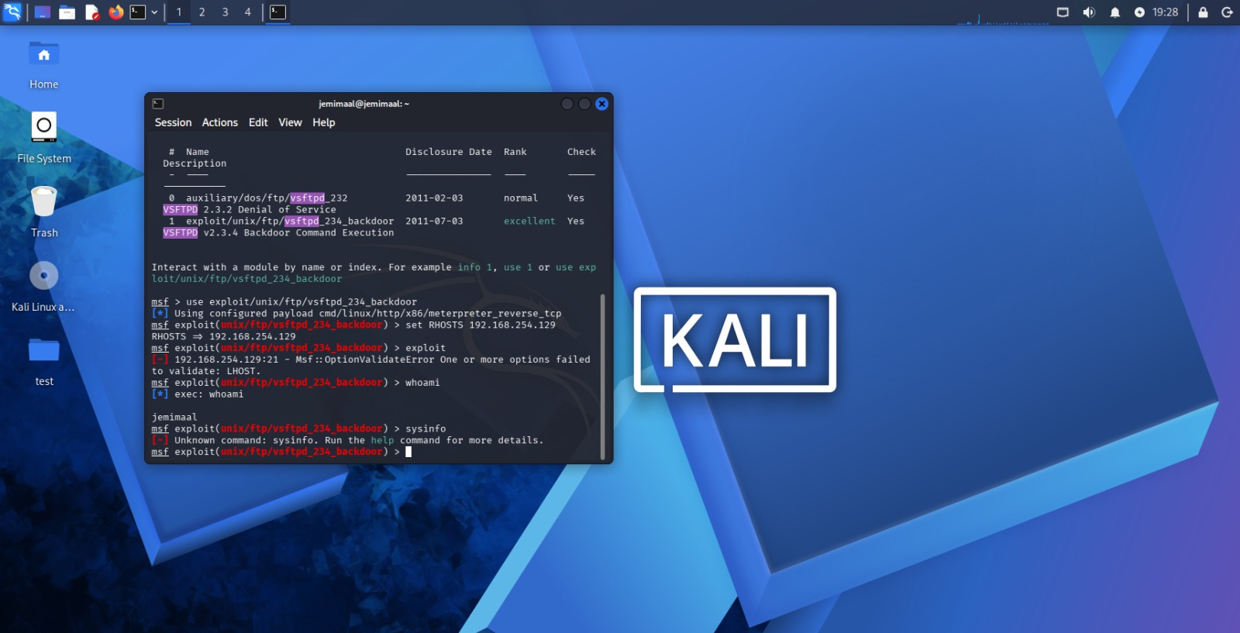
Fig 11: Select Exploit , Configure Target IP , Run Exploit , Verify Access

STEP: 3 - PASSWORD ATTACKS
- Objective: Demonstrate password attack.
- Password attacks were performed to understand the importance of strong passwords and password security. Hydra was used to perform a brute-force attack against an SSH login service.
The commands used were:
- sudo gzip -d /usr/share/wordlists/rockyou.txt.gz
- hydra -l user -P /usr/share/wordlists/rockyou.txt ssh://<target-ip>
- John the Ripper was also used to crack password hashes. Password hashes stored in a text file were analyzed and compared against wordlists to recover weak passwords successfully.
Commands used:
- john hashes.txt
- john --show hashes.txt
These activities demonstrated how weak passwords can be easily compromised and highlighted the importance of strong password policies.
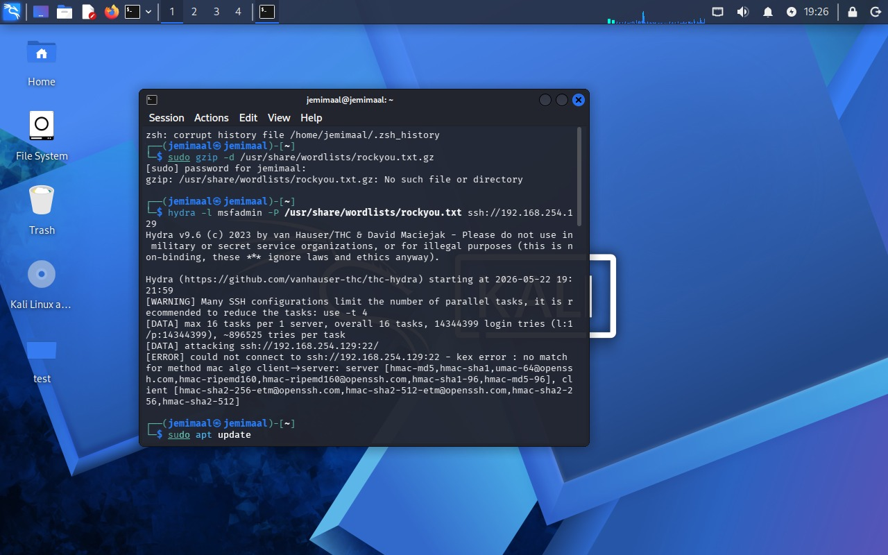
Fig 12: Extract RockYou Wordlist

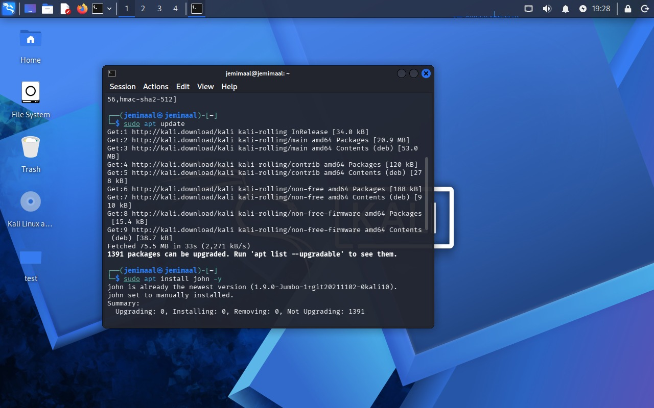
Fig 13: Run Hydra Attack , Install John the Ripper

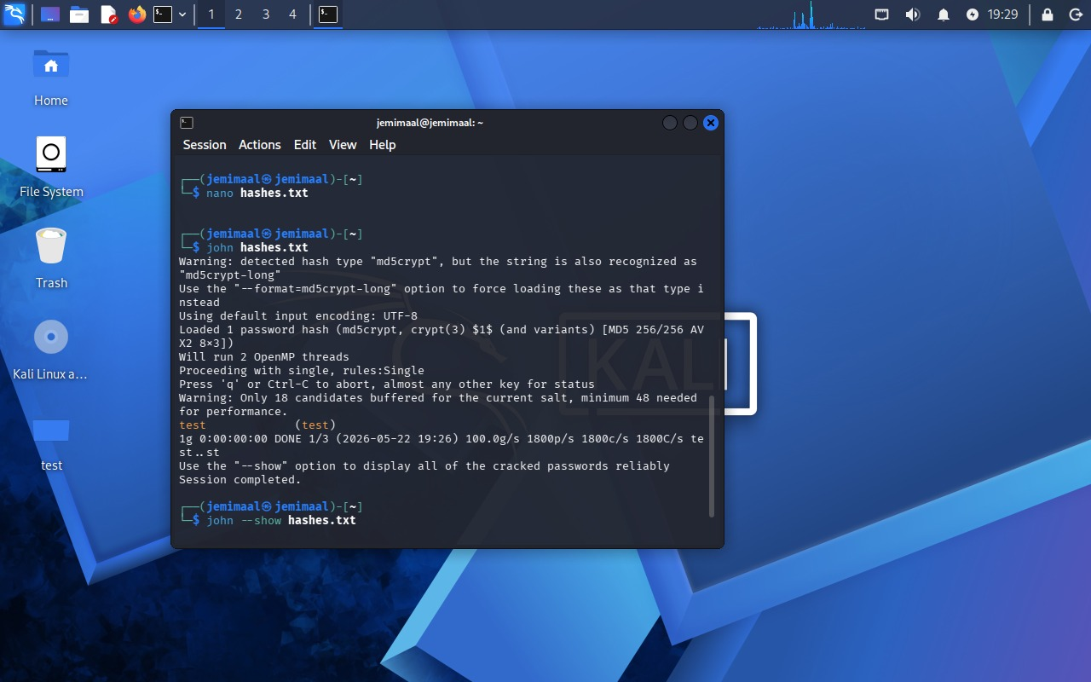
Fig 14: Start Password Cracking

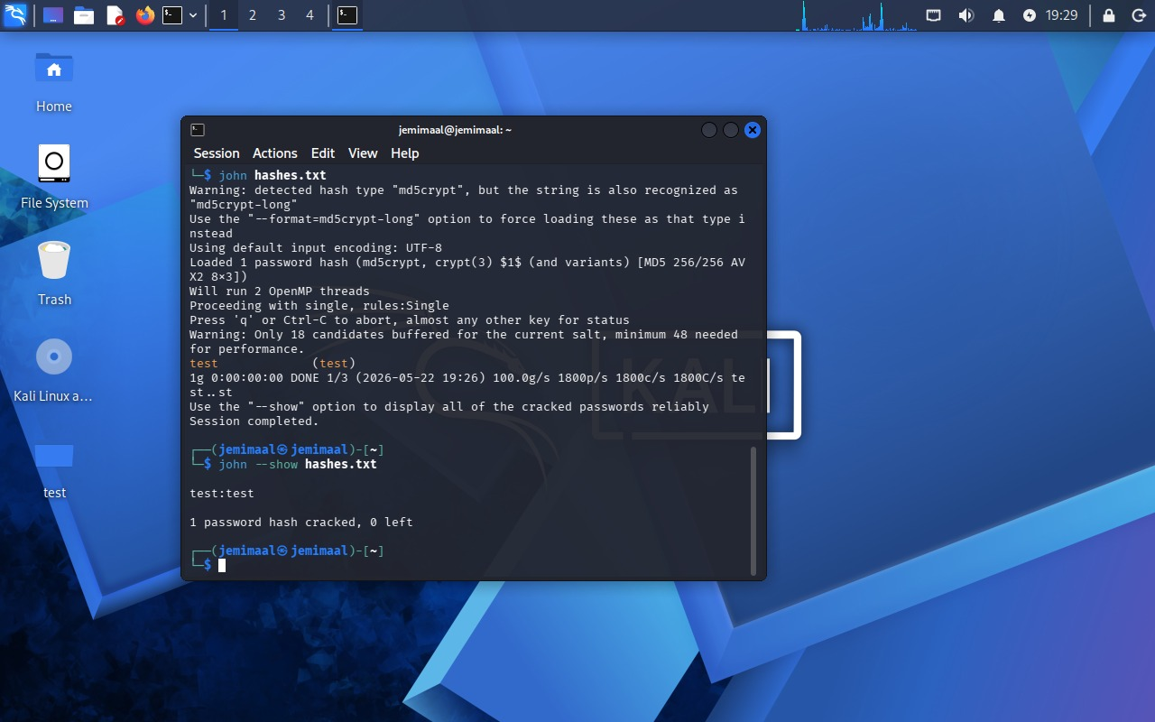
Fig 15: Display Cracked Password

STEP: 4 - SOCIAL ENGINEERING
- Objective: Create awareness demo page.

- Social engineering awareness was studied to understand how attackers manipulate users into revealing sensitive information. Phishing attack techniques and email spoofing concepts were analyzed during the task.
- Awareness methods for identifying suspicious emails and fraudulent websites were also learned. Preventive measures such as verifying email senders, avoiding unknown links, and enabling multi-factor authentication were discussed to improve cybersecurity awareness.

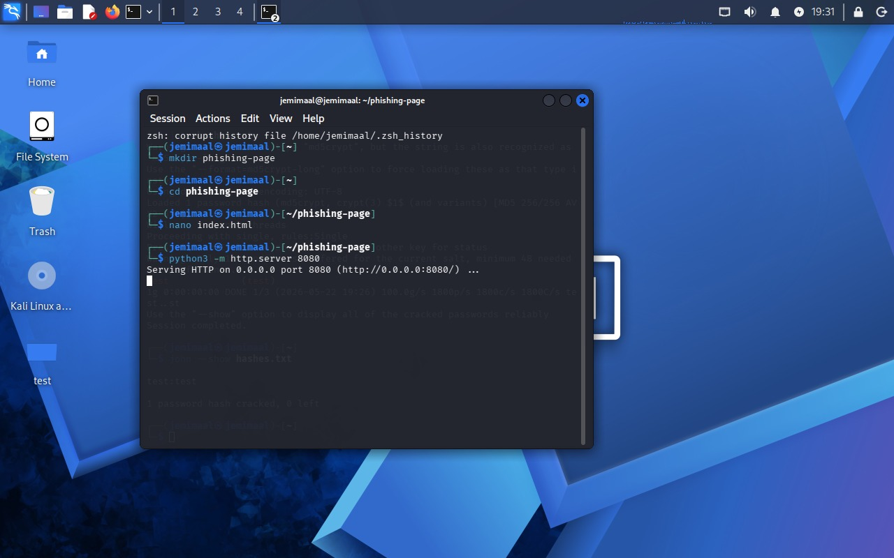
Fig 16: phishing awareness demonstration
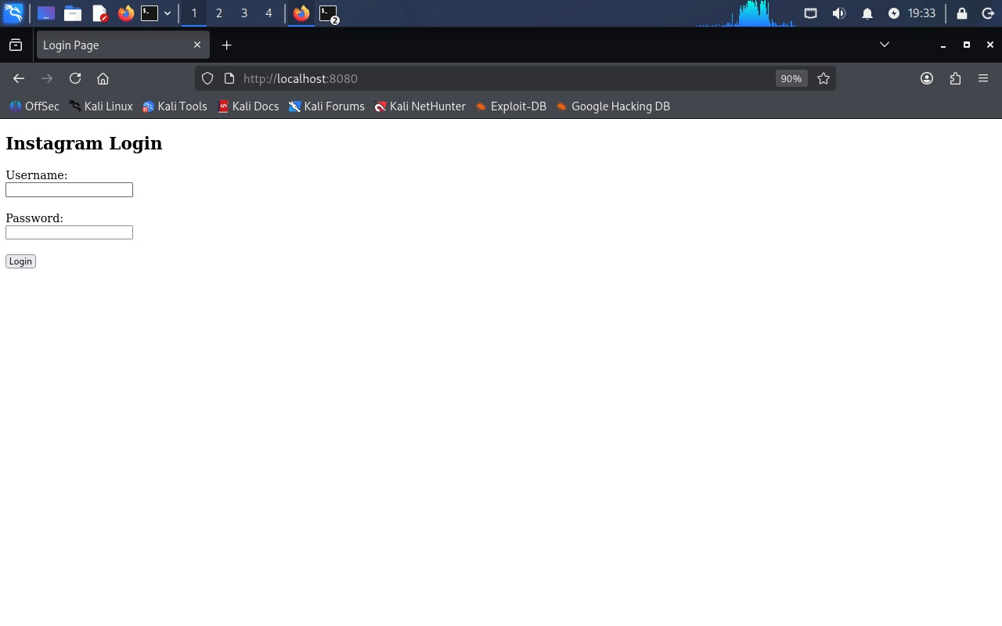
Fig 17: Login Interface

STEP: 5 - MALWARE BASICS
- Objective: Understand malware analysis safely.

- Malware basics were studied to understand how malicious software behaves and affects computer systems. Both static analysis and dynamic analysis techniques were explored during the task.
- This activity helped in understanding malware behavior, infection techniques, and defensive security practices.

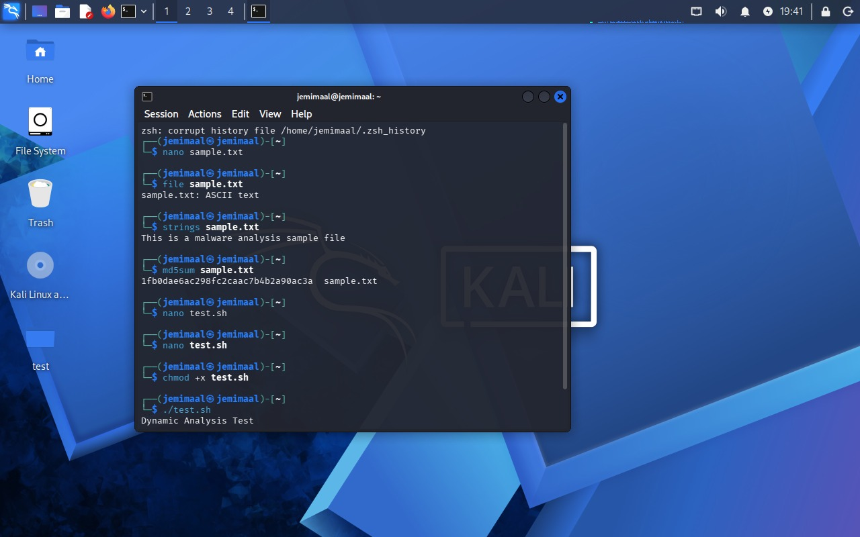
Fig 18: Create Sample File

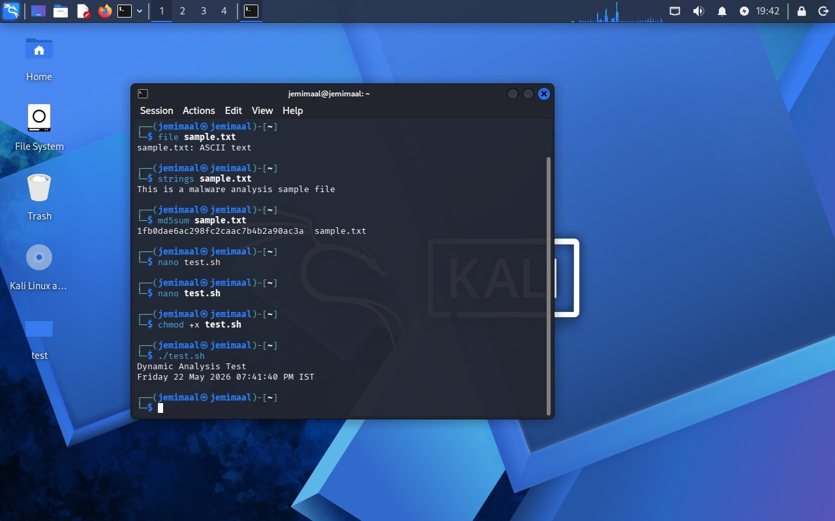
Fig 19: Dynamic Analysis

STEP: 6 - SYSTEM HARDENING
- Objective: Improve system security.

- System hardening techniques were implemented to improve overall system security. Security patches and updates were applied to reduce vulnerabilities.
- Firewall configurations were also performed to restrict unauthorized network access. Unused services were disabled to minimize attack surfaces, and strong password practices were encouraged for better system protection.
The following commands were used:
- sudo ufw enable
- sudo ufw status

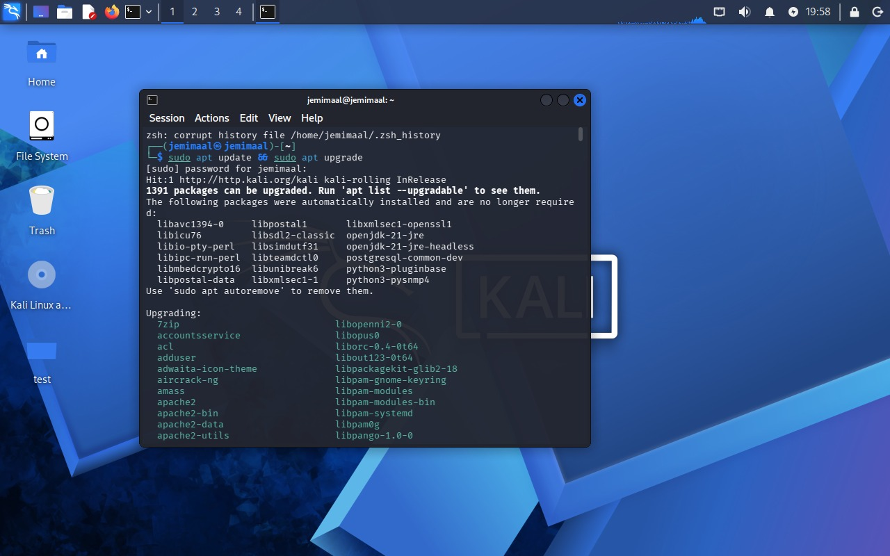
Fig 20: Update System Packages

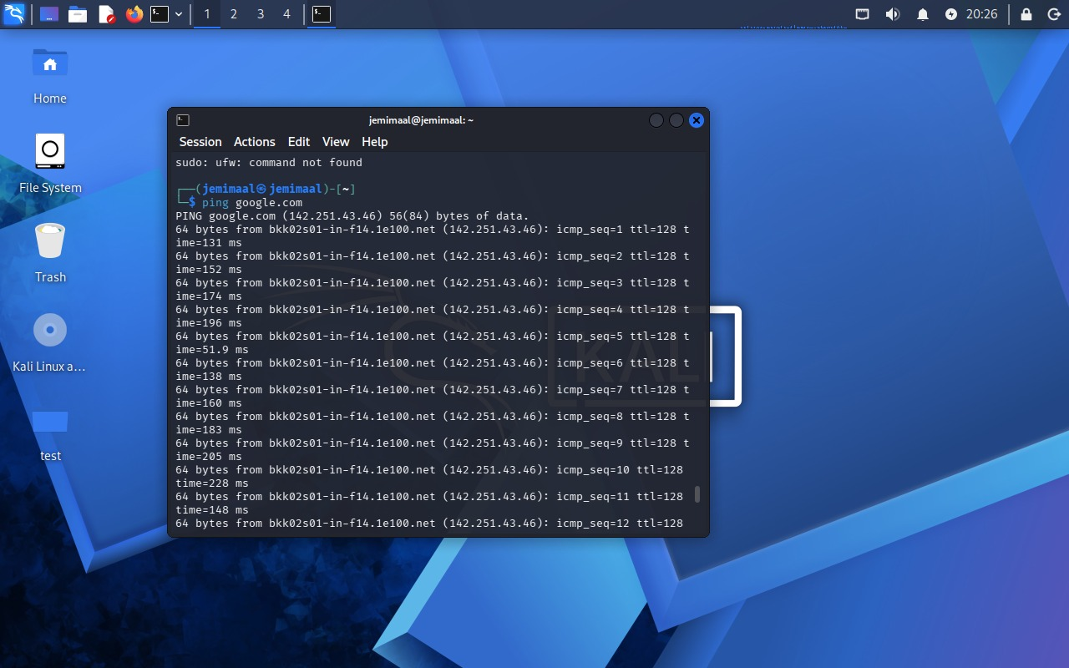
Fig 21: ping

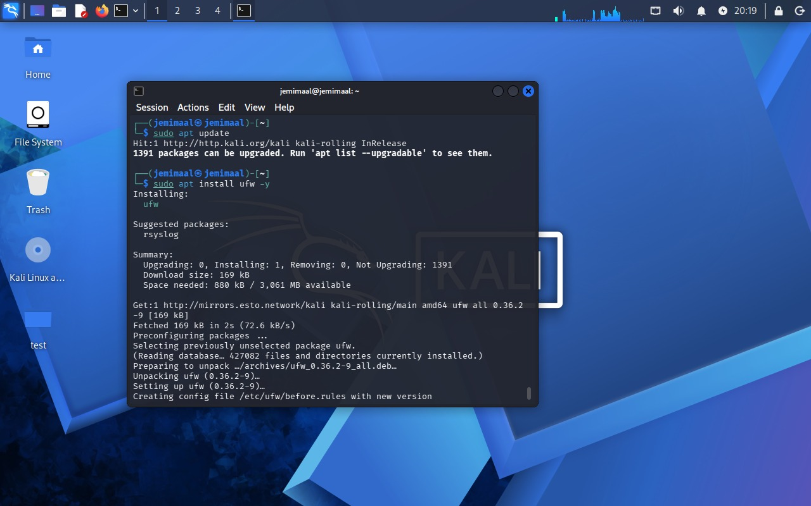
Fig 22: ufw installation

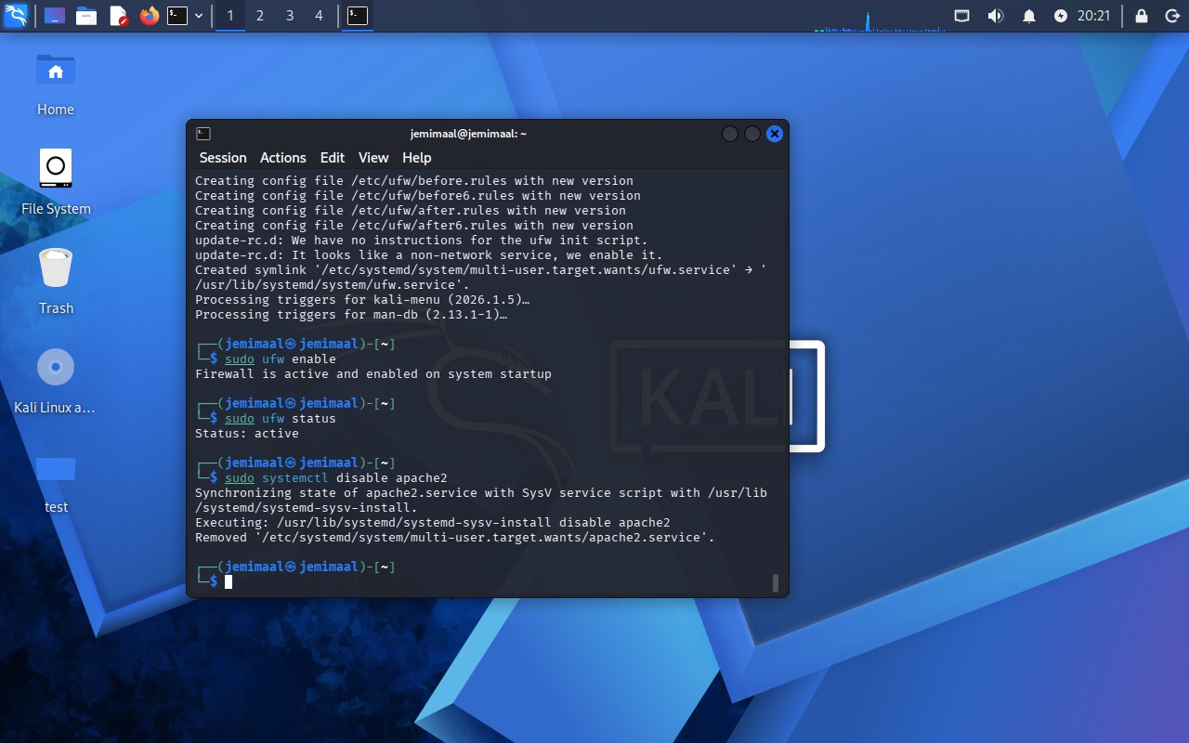
Fig 23: Enable Firewall Protection

